**Feedback in Context**: Using a Code Review Tool for Program Grading

<https://doi.org/10.1145/3478431.3499402>

Tool Analysis by: Truța Dan-Alexandru, Vintilă Dragoș

***Prerequisites***

Before trying the code review tool, Visual Studio Code must be installed on your computer. It's available for Windows, macOS, and Linux from the official website: <https://code.visualstudio.com/>.

***Installation***

1. Open *Visual Studio Code*.
2. Access the *Extensions Marketplace* by pressing Ctrl+Shift+X or navigating to the *Extensions* view by clicking on the square icon on the sidebar.

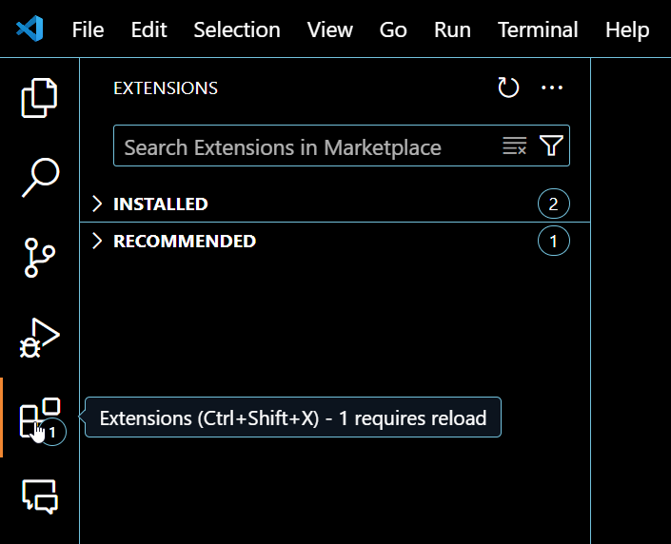

1. Search for the *Code Review Tool* by typing "code review" in the search bar. There are several extensions available for code review. The tool presented in the paper is the one developed by Danny Koppenhagen. Click on it and it will open on the screen.

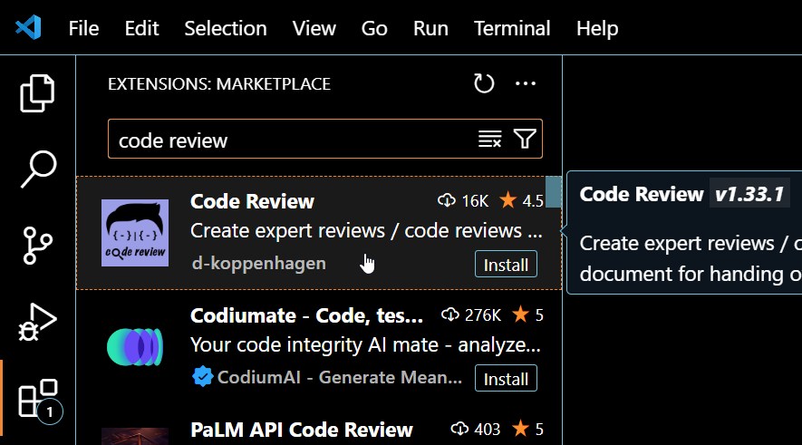

1. Click on the install button on the freshly opened screen. You can also see here more detailed information about the implemented tool.

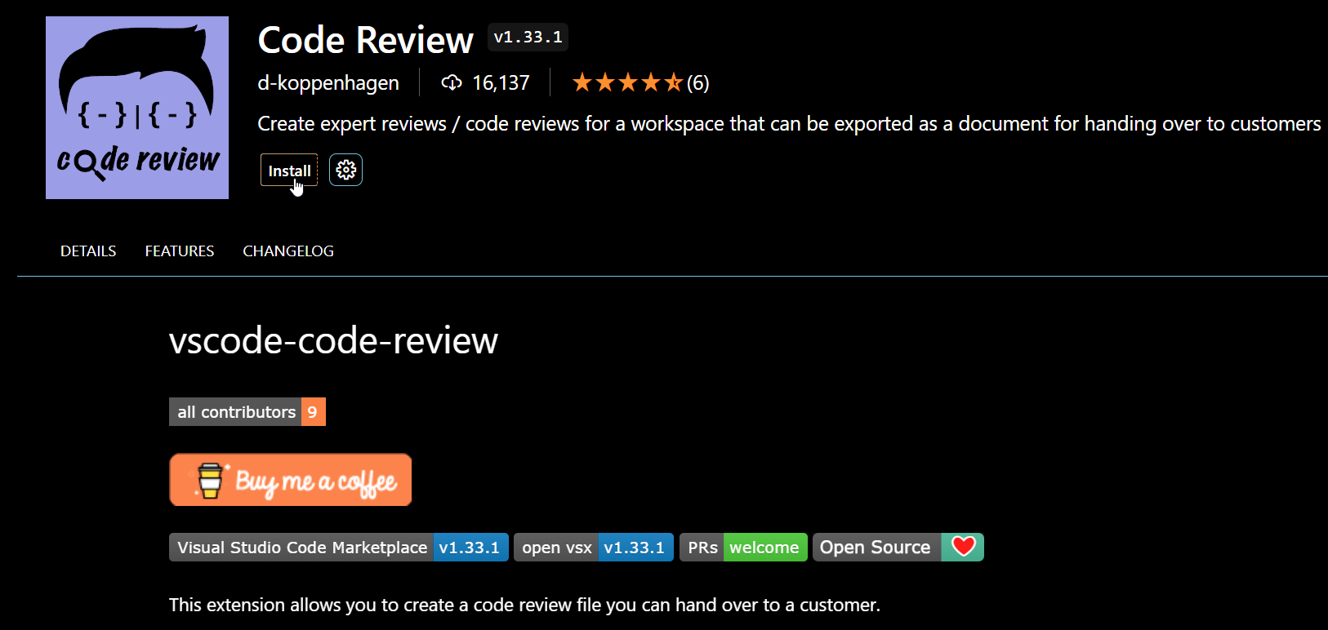

***Usage***

Navigate to the file you want to review. In our case, we are going to use a C++ file we created a long time ago for an OOP assignment.

Highlight the line or block of code you wish to comment on. Right-click and select the option to “Code Review: Add Note”.

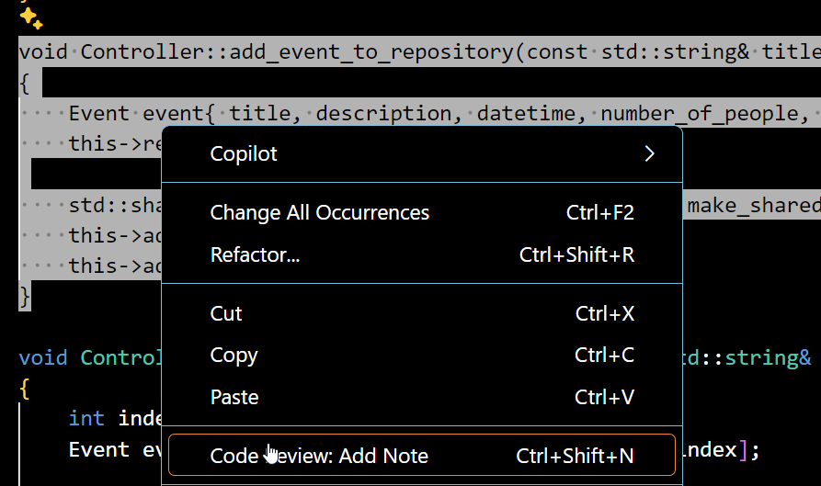

Type your review comments. Each code comment has 5 components: a

title, a category, a priority, a description, and a place for additional

notes.

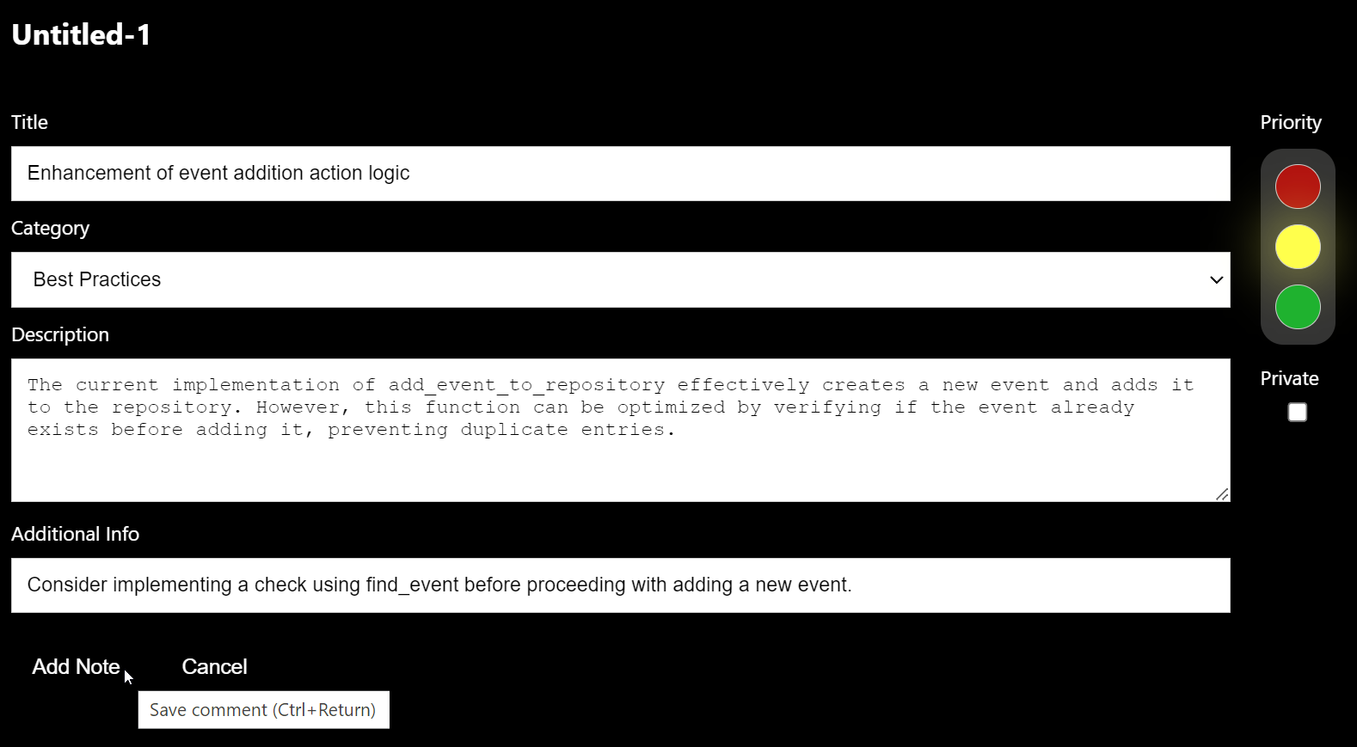

After completing the components, you can press “Add Note” button, in order to save the comment.

All other capabilities will be presented in the video presentation.

***Conclusions***

Installation can be considered easy for most users. However, specific challenges might arise, such as export location issues, which could complicate the usage of the tool for some users. Other than that, utilizing the tool post-installation is intuitive for individuals familiar with Visual Studio Code.

The tool creates clear communication among instructors and students by providing a clean platform for detailed feedback and discussions within the codebase itself. The tool allows for the customization of review templates, enabling instructors to tailor the review process to their specific needs and preferences. The tool can also help maintain a history of reviews and feedback.